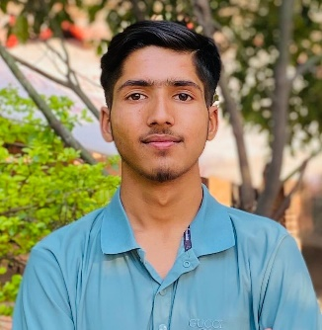 **Ashish Paudel (Frontend Developer)**

**Address**: Baneshwor, Kathmandu

**Email:** ashishpaudel206058@gmail.com

**LinkedIn:** [linkedin.com/in/ashish-paudel-2b72962ab/](https://www.linkedin.com/in/ashish-paudel-2b72962ab/)

**Portfolio:** [paudel-ashish.com.np](https://www.paudel-ashish.com.np/)

**GitHub:** [github.com/ashishpaudel123](https://github.com/ashishpaudel123)

**Gender:** Male **DOB:** 20 Nov 2005 **Nationality:** Nepalese

**OBJECTIVE**

To utilize my creativity and developing skills as Frontend Developer to create visually appealing, user-friendly, responsive web designs and contribute effectively to the success of the team project.

**Education**

**Bachelor of Information Technology (BIT)**

Himalayan Whitehouse Int’l College

* 2023 – Present

**Technical Skills**

* **Languages:** HTML5, CSS3, JavaScript (ES6)
* **Frameworks/Libraries:** React.js, Next.js, Bootstrap, Tailwind CSS
* **Version Control:** Git, GitHub
* **Tools:** Visual Studio Code, Figma
* **Other:** Well versed in developing pixel-perfect design, can build fast, responsive design with creative ideas. Updated with latest trend to keep fresh and cutting design.

**Soft Skills**

* Creative and User centric design
* Problem solving and innovative
* Interpersonal and dedication
* Team work

**Projects**

1. **Personal Portfolio (HTML/CSS/JavaScript)**

Designed and developed a personal portfolio website using HTML, CSS and JavaScript to showcase projects and skills, using animations for effects and transitions for visual effects. [🔗](https://paudel-ashish.com.np/)

1. **E-commerce Website (React.js)**

Developed a e-commerce website with React.js, enabling users to browse products, add items to a cart and favorites, integrated API calls for product data, and used React Hooks and styled components for enhanced UI/UX. [🔗](https://shop-react-zeta.vercel.app/)

1. **Laghubitta News Website (React.js)**

Developed a dynamic news website with React.js, letting users browse the latest articles by category and fetch real-time updates via an API. [🔗](https://lagubitta-ashish-paudels-projects.vercel.app/)

1. **Banking News Website (Next.js)**

Developed a dynamic news website using Next.js for SEO optimization and used Bootstrap for a clean, responsive design. [🔗](https://bankingkhabar.vercel.app/)

1. **Laundry Website (Next.js)**

Developed a visually appealing laundry website with Next.js, focusing on beautiful design, routing, and rendering concepts for a seamless user experience. [🔗](https://web-laundary-hal5-git-main-ashish-paudels-projects.vercel.app/)

**Certifications**

**Web designer – Broadway Infosys, [2025]**

**Languages**

* English, Nepali and Hindi

*I hereby declare that all the above information is true and correct. I will be responsible for any discrepancy.*